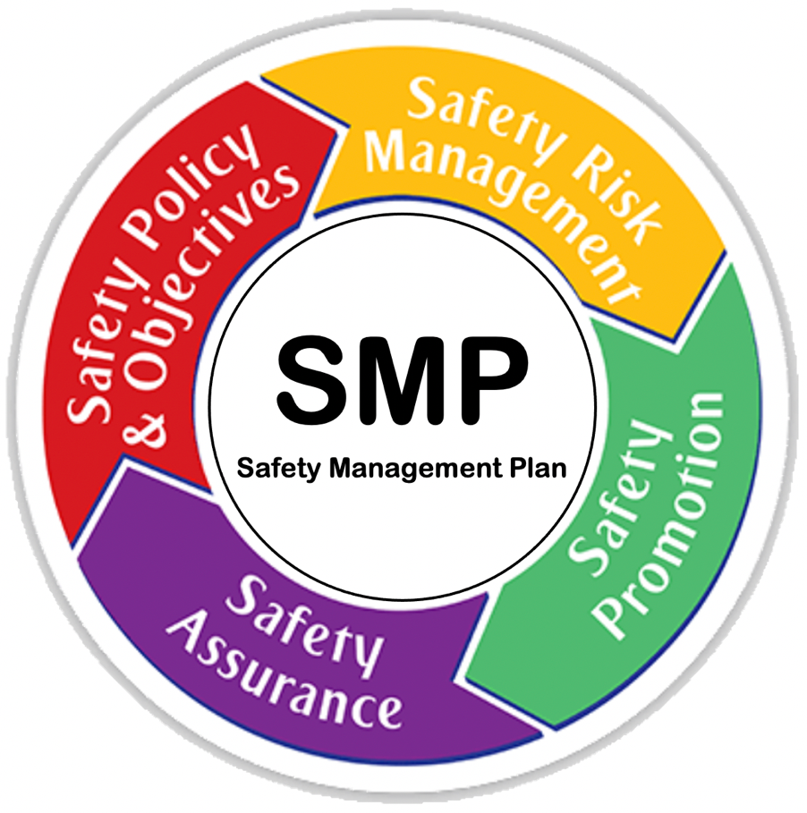
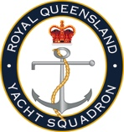
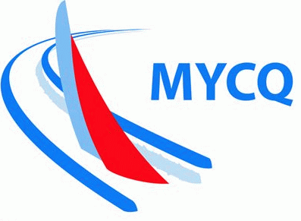
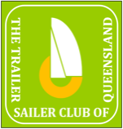
MANLY COMBINED CLUBS
SAFETY MANAGEMENT PLAN
REVISION 2

PURPOSE

This Safety Management Plan (SMP) has been created to help ensure the safety of participants in events run by the Sailing Group of Moreton Bay Trailer Boat Club (MBTBC), including Manly Combined Clubs (MCC) races and events.

This SMP defines the policies, procedures and responsibilities in place to manage risks and minimise the likelihood of injuries and marine incidents.

APPLICATION & LIMITATIONS

The application of this SMP is limited to vessels and crews participating in Moreton Bay Trailer Boat Club (MBTBC) sanctioned racing or cruising events.

The area of application of this SMP is limited to the waters within Moreton Bay, QLD and the course areas as defined by The Manly Combined Clubs Course Book – as posted to: manlycombinedclubs.com

This SMP does not apply to events conducted outside the defined area or requiring higher levels of safety than Category 5 (or 5N) Races as defined by Australian Sailing (AS) Special Regulations – Safety.

POLICIES, ROLES & RESPONSIBILITIES

Safety Policy

All activities, procedures and processes must comply and be consistent with the Safety Policy of MCC. The policy is included as Appendix A to this SMP.

Safety is paramount for MCC events. If there is a risk of serious injury to participants, the event is to be suspended until it is considered safe to continue.

Roles & Responsibilities

MCC Organisation
- The MCC Organisation consists of an MCC Committee led by the Sailing Captain of MBTBC.
- The MCC Committee reports to and is accountable to the Sailing Group of MBTBC. The Sailing Group reports to and is accountable to the Committee of MBTBC.

Persons in Charge
- The Persons in Charge of vessels participating in MCC events are the skippers of the boats. They are responsible for all actions, activities and responses on their vessels.
- They are required to ensure that they, and all crew, are familiar with the requirements of the Notices of Race, Sailing Instructions and Race Briefings.
- They shall ensure that the Directions of Race Officials are followed.

Race Officials – The role of Race Officer (RO)
- The RO controls the race events, monitors radio communications and can initiate rescue procedures if required.
- The RO shall conduct a pre-race briefing before each sanctioned event. The course is determined and the weather and tides for the day will be discussed to give participants an idea of what to expect during the event.
- The RO is responsible for maintaining a register of all entrants. This involves noting each entry’s status at the completion of the event: did not start, retired (safe port return confirmed) and finished.
- In the absence of a designated RO, the MBTBC Sailing Group Captain shall assume the responsibilities of the RO and shall delegate tasks as required on the day.
- The race control hierarchy shall be:
  - RO, then
  - MBTBC Sailing Group Captain, then
  - Persons in Charge (the Skippers)

Authorisations

Aquatic Event Authority
- An aquatic event is an organised on-water activity, such as an MCC sailing event, that is likely to affect the normal operation of ships in the area of the event.
- To hold an aquatic event an aquatic event authority is required.
- Maritime Safety Queensland is responsible for the management of aquatic events in Queensland waterways, except for Gold Coast waterways.
- An aquatic event application form must be lodged with the local Maritime Safety Queensland regional office and payment of a fee.
- MCC shall apply for an Aquatic Event Authority annually to cover the events planned for the coming year.

PROCEDURES

Key Governing Documents

Notice of Race
- The Notice of Race (NOR) is the principal document that describes each MCC event. It also defines the requirements of entrants, in order that these be clearly understood before entering an event.
- Amongst other things, the NOR specifically addresses a number of important safety and risk management matters, including:
  - The Venue
  - Eligibility of Entries
  - Schedule of Races
  - Insurance Requirements
  - The Entry Process
  - Liabilities
  - The Applicable Rules
  - Relationship to the Sailing Instructions

Sailing Instructions
- The Sailing Instructions (SI) define the detailed matters that relate to the way in which events and races are conducted on the day. All of the requirements of the NOR apply in addition to the matters addressed by the SI.
- Amongst other things, the SI specifically addresses a number of important safety and risk management matters, including:
  - Relationship to NOR
  - Liabilities
  - Safety and Race Procedures
  - Schedule of Races
  - The Courses
  - The Finish
  - Time Limits
  - Crew Registration Process

Conduct of a Race

Races will be conducted in accordance with the Sailing Instructions.

Race and Safety Briefings
- A briefing for all sailors shall be conducted by the Sailing Group Captain (or delegate) and the Race Officer (for a race) prior to the start of the event.
- The pre-event briefing shall include:
  - Safety Moment and Reminders
  - Changes to Sailing Instructions
  - Selected course
  - Expected tide, wind and weather conditions
  - Other relevant information known at the time.

Emergency Response
- The MCC Emergency Response Plan (ERP) will be followed in the event of an emergency.
- All Persons in Charge are required to be familiar with the ERP and shall have a laminated copy of the ERP flowchart onboard.
- Any Person in Charge that determines that an emergency exists shall initiate emergency procedures according to the ERP.

TRAINING & INDUCTION

MCC Volunteers

All MCC volunteers, including Race Officials will be provided with a training session prior to the commencement of each year of sailing. The training shall address the content, purpose and procedures associated with each of:
- The NOR
- The SI
- The SMP
- The ERP

MCC Event Participants and Entrants

All MCC event participants and entrants are required to attend a season kick-off and familiarisation session to be held prior to the first race. As a minimum, the session will address the content, purpose and procedures associated with each of:
- The SI
- The ERP

RISK MANAGEMENT

The MCC Committee is responsible for Risk Management and conducting Risk Assessments. This SMP is the principal guide in setting expectations regarding safety and risk management.

Risk Management involves developing a Risk Management Plan, including the identification of threats and risks, and the mitigation and management of the risks.

Management of the risks typically involves a multi-faceted approach. These facets should include consideration of some or all of the following:

Providing Warnings
- The warnings must be reasonable and must identify the general nature of the risks.

Positive Mitigation Action
- This can be as simple as regular checks and maintenance of equipment and infrastructure.
- This would include making sure that the race management team is aware of things like BOM strong wind warnings, commercial shipping movements, and, either communicating these to the participants or setting courses appropriately.

Positive Remediation
- Included are things like having First Aid kits on site.

Incident Management – the ERP
- This includes a plan should something happen. The ERP shall identify the ‘incident response team’, which might be no more than one or two people who know exactly what to do when something bad happens.
- The team manages the incident to conclusion. This might be something as simple as a minor injury to someone through to a major disaster. Regardless, the team must know what to do, who to call etc. When the incident is over, they must record the details.
- The incident management team should be familiar with the practical nature of how to respond in the event of a major incident, not just have read the ERP.

Awareness
- Every club member needs to know that the club has a Risk Management Plan. The Plan should be readily available to all members, preferably on a website.

Insurance
- It is important to understand the insurances in place and how they cover the risks, if all else fails.

SUPERVISION & GOVERNANCE

The MCC Committee reports to and is accountable to the MBTBC Committee. All important matters related to safety must be escalated to the MCC Committee as soon as is possible.

RECORDS & REPORTING

Safety Records

Records of each event shall be kept and retained for 12-month period including:
- Participants
- Boats
- Withdrawals and reasons for withdrawal
- Reported Injuries
- Maximum wind speed measured at the Start/Finish Boat and time of day when it occurred
- Emergency Incidents, as per the ERP

Reporting

All safety records shall be forwarded to the MBTBC Sailing Captain, as soon as is practicable.

APPENDIX A - MCC SAFETY POLICY
