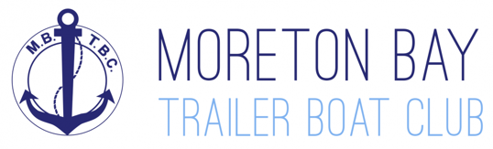

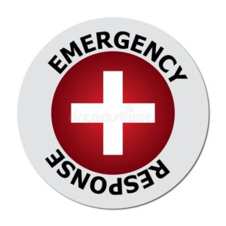
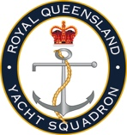
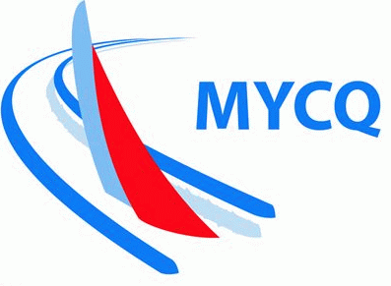
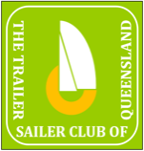
MANLY COMBINED CLUBS
EMERGENCY RESPONSE PLAN
What to do during an emergency
Note: Emergency Response Card to be kept near VHF on all boats

REVISION 3

PURPOSE

This Emergency Response Plan (ERP) defines the way in which emergencies are responded to during events run by the Sailing Group of Moreton Bay Trailer Boat Club (MBTBC), including Manly Combined Clubs (MCC) races and events.

APPLICATION & LIMITATIONS

The application of this ERP is limited to vessels and crews participating in Moreton Bay Trailer Boat Club (MBTBC) sanctioned racing or cruising events.

The area of application of this ERP is limited to the waters within Moreton Bay, QLD and the course areas as defined by The Manly Combined Clubs Course Book – as posted to: manlycombinedclubs.com

This ERP does not apply to events conducted outside the defined area or requiring higher levels of safety than Category 5 (or 5N) Races as defined by Australian Sailing (AS) Special Regulations – Safety.

EMERGENCY TYPES

This plan is intended to address any incident that may occur during an MCC event.

The level of severity of an emergency will dictate the response required. There are three levels of emergency defined by this ERP as follows:

Level 1 – Code Red, which includes:
- Potential or Actual Loss of Life
- MOB more than 5 minutes
- Boat Sinking or Capsize
- Fire or Explosion Onboard

Level 2 – Code Orange, which includes:
- Serious Injury
- Person Unconscious
- Person Severely Unwell
- Major Damage to Vessel
- MOB less than 5 Minutes
- Missing Boat

Level 3 – Code Yellow, which includes:
- Minor Injury with First Aid
- Minor Damage to Boat due to Collision or Grounding
- Mechanical Failure
- Occurrence of Severe Weather
- Need to contact Crew Member

ROLES & RESPONSIBILITIES

In the event of an emergency, responsibilities are generally as follows, with details of responses for each level of emergency defined on the Emergency Response Card, which is included as Appendix A. Each boat shall have a laminated copy of the Emergency Response Card onboard and located close to the primary radio.:

Persons in Charge – the Boat Skippers
- Determines the level of severity of an incident.
- Directs crew to respond to the emergency, including in the use of safety and emergency equipment onboard
- Assigns a person to be the dedicated Radio Operator (RO) who will
  - Communicate with emergency services and Race Control
  - Record radio communications
  - Maintain communication with the boat’s Skipper
- Note re Post Emergency: All marine incidents must be reported to the Race Officer. It is also a regulatory requirement to report all marine incidents to Maritime Safety Queensland.

Race Officer (RO) – typically onboard the Start/Finish Boat
- Becomes the initial leader of the Response Team
- Assigns a person to be the dedicated Radio Operator (RO) who will
  - Respond to Calls
  - Liaise with Emergency Services, if required
  - Record Radio Traffic and timings
  - Handover to Emergency Services, if required

Response Team
- A full Response Team will be formed as soon as is practicable and shall consist of:
  - MBTBC Sailing Captain (Chair)
  - MBTBC Vice Captain
  - Race Officer
  - Others, as deemed necessary by the Chair
- Manages the response to the emergency without compromising the actions and communications of the Emergency Response Services.
- Collates records after the event, from the vessels involved in the incident, including the Start/Finish Boat.
- Informs regulatory authorities of the details of the incident, to the extent required by law.
- Informs and advises the MBTBC Committee, as required.
- Prepares a report of the incident
- Identifies any improvements that could be made to the SMP and ERP

The MCC Committee
- Is responsible for the maintenance, improvement, updating and communication of this plan

APPENDIX A - MCC EMERGENCY RESPONSE CARD
Note: To be printed on A4, two sided, laminated and kept near and on display at the primary VHF Radio of all boats
